**25K Dataset Model Evaluations Saturday 29 August 2020**

**Exp 6 – LHS**

**Two-Class Averaged Perceptron - v – Two-Class Boosted Decision Tree**

Two-Class Averaged Perceptron

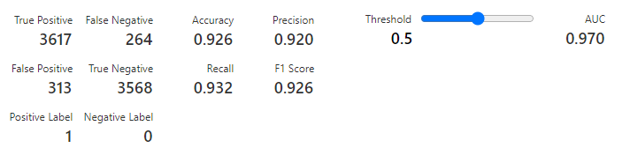

Two-Class Boosted Decision Tree

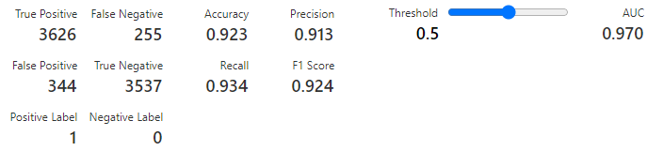

**Exp 6 – RHS**

**Two-Class Support Vector Machine - v – Two-Class Logistic Regression**

Two-Class Support Vector Machine

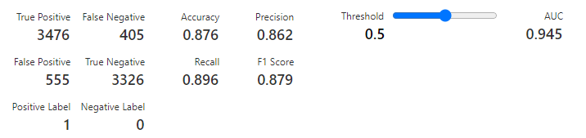

Two-Class Logistic Regression

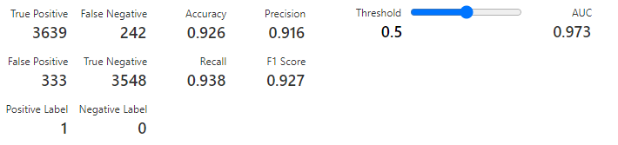

**Exp 7 – LHS**

**Two-Class Decision Forest - v – Two-Class Decision Jungle**

Two-Class Decision Forest

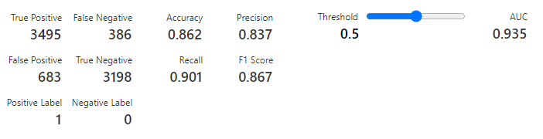

Two-Class Boosted Decision jungle

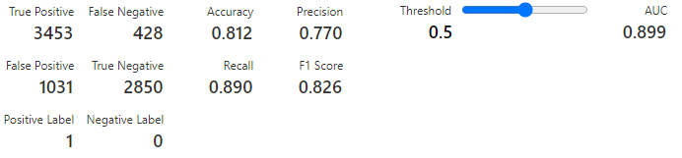

**Exp 6 – RHS**

**Two-Class Locally Deep Support Vector Machine - v – Two-Class Neural Network**

Two-Class Locally Deep Support Vector Machine

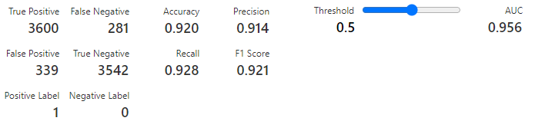

Two-Class Neural Network

